Website Planning Document

# Site Name

The Mountain Spoke

# Site Purpose

A website for a fictitious bicycle shop that sells bicycles, bicycle parts, bicycle repair, and tours. “The goal is to provide a fresh new website experience for their clients and potential clients that reflects their culture of bicycle enthusiasm with products, repair service, parts, and tour trips.”

# Target Audience

Bicycle enthusiasts – at all levels.

# Sitemap

A close up of a logo

Description generated with very high confidence



# Color Scheme

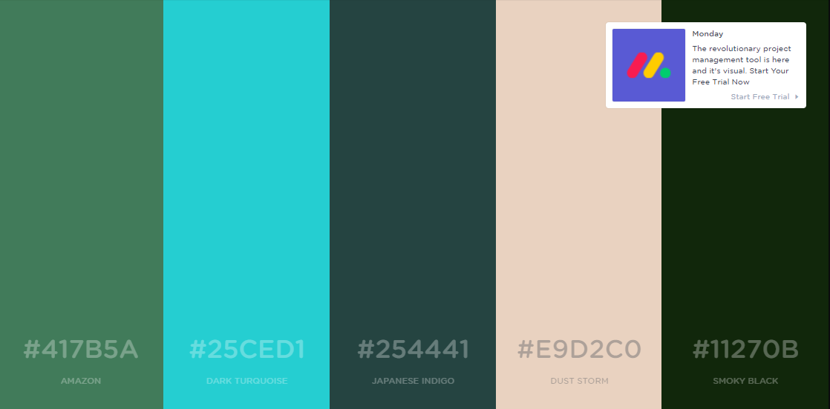

# Typography

<https://fonts.google.com/specimen/Raleway> - <https://fonts.google.com/specimen/Amatic+SC>

<https://fonts.google.com/specimen/Satisfy>





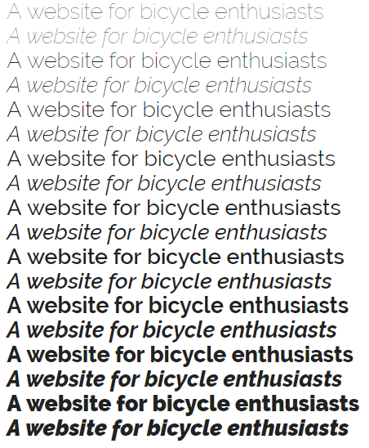

# Wire Frames

Small Medium Large

A close up of text on a white background

Description generated with high confidence A close up of text on a white background

Description generated with high confidence A picture containing text

Description generated with very high confidence